LINUX PROGRAMMING
LAB EXERCISE-10
DATE : 06/06/2020
NAME : ANJANA .P
REG.NO:17MIS1028

1) CODE:
sudo apt-get install sl
sl

OUTPUT:

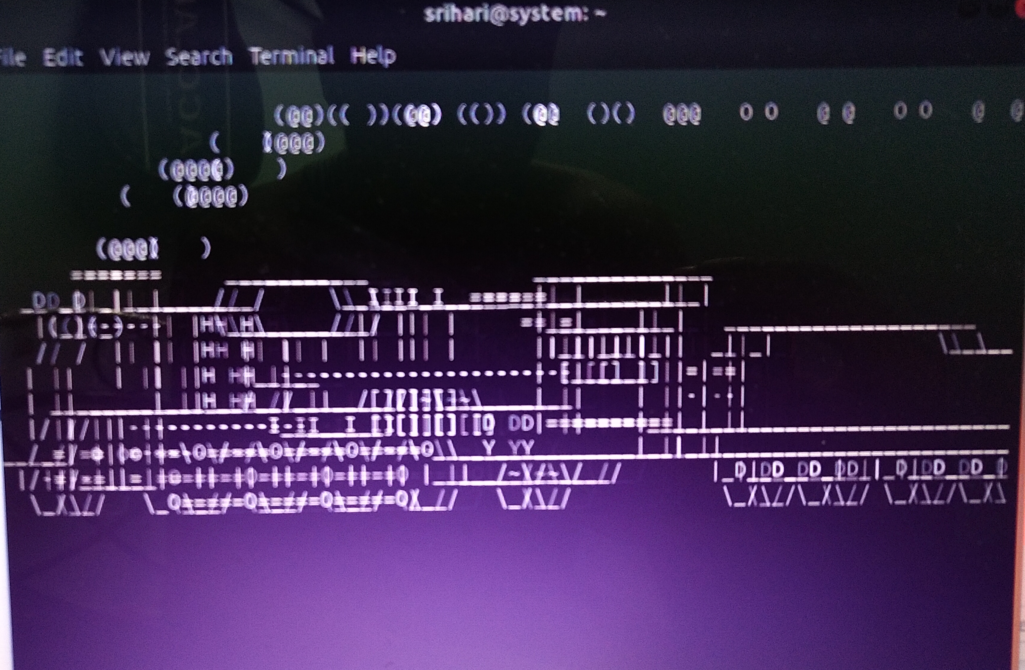

2)CODE:
rev
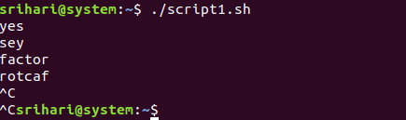
OUTPUT:

3) Write a bash script to monitor health of the system.

Health.sh:
vmstat 1200 > vmstat1.data
filename= "/hP/user/linux/vmstat1.data"
tail -f $filename |
while read $line do
if [ (cat vmstat1.data | grep "swap")>0 ]
then
echo "some rogue process has consumed massive amounts of memory"> swap.txt
fi
if [ (cat vmstat1.data | grep "r")>1 ]
then
echo "some process are waiting to execute"> runqueue.txt
fi
if [ (cat vmstat1.data | grep "cpu")>1000 ]
then
echo "cpu usage is more"> cpu.txt
fi
End

EXPLANATION:

the vmstat 1200 – monitors every 24 hours and puts the data into the vmstat1.data

grep “swap”- the swap should always be zero if its not then some process has consumed massive memory. That will be monitored in this line

grep “r”- the running queue is constantly above process 1 it indicates the system is slow and some process is waiting to be executed. That will be monitored here.

Grep “cpu”- it indicates the cpu usage of the system. If the cpu usage is more it will be monitored and will alert in this line.

GITHUB LINK:

https://github.com/Anjanapradeep/Linux-

